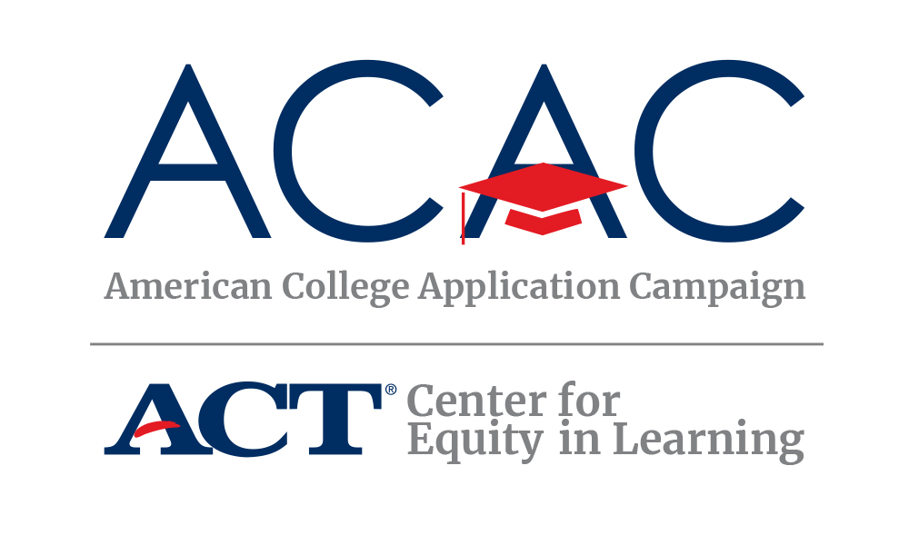

Find a teacher, administrator, or other adult in your school for whom the following statements about college experiences are true. Ask that person to sign the box that contains their true statement. Up to 5 people may sign your sheet twice. Five in a row wins – horizontal, vertical, or diagonal.

HUMAN BINGO CARD

Never thought they would go to college | Went to a state public university | Had a job while in college | Lived in a dorm | Played a varsity sport while in college
Had an internship | Graduated in 4 years | Was the first in their family to go to college | Went to a private college | Took out loans to help pay for college
Studied on a Saturday night while they were in college | Changed their major at least one time | FREE  SPACE | Received a scholarship to help pay for college | Went to a party during college
Belonged to a fraternity or sorority | Was a member of the student government association | Studied overseas while in college | Transferred from one college to another | Went more than 500 miles away from home
Lived at home during college | Went to a community college | Was in college for more than 4 years | Belonged to a student group | Did scientific research

Available at: https://equityinlearning.act.org/acac/resources/site-coordinator-materials/

Educators: The purpose of Human Bingo is to demonstrate to students the variety of college experiences that adults in the school have and to reinforce that adults in their schools are “ready resources” for college information. Credit for this activity goes to Oregon GEAR UP and Washington State’s GEAR UP Program. If you’d like to create more than one bingo board, please use the blank one below.

HUMAN BINGO CARD

FREE
SPACE

